**Mr. Visca’s: Calculus (sec 7.1)**

**Chpt 7 – Day 1: Integral as Net Change**

Distance Traveled vs. Displacement



A honey bee makes several trips from the hive to a flower garden.

The velocity graph is shown below.

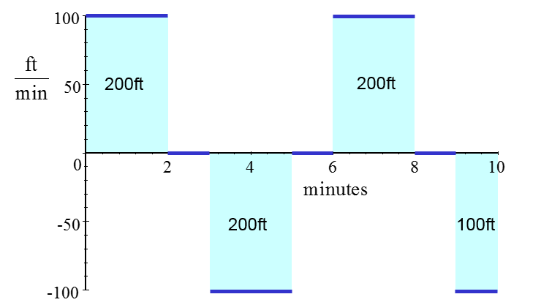

What is the total **distance** What is the **displacement** of **traveled** by the bee? the bee?

Therefore...

Distance Traveled = Displacement =

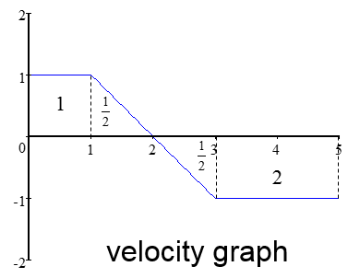

Displacement:

Distance Traveled:

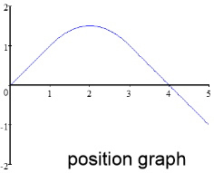

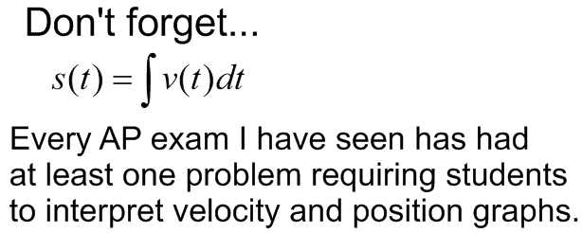

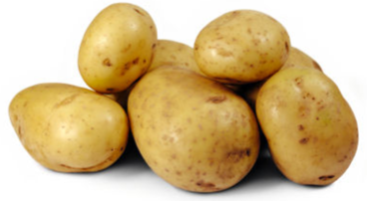Ex1. National Potato Consumption

The rate of potato consumption for a particular country was:

C(t) = 2.2 + 1.1t

where *t* is the number of years since 1970 and *C* is in millions. For a small ∆t, the rate of consumption is constant.

The amount consumed during that short time is ______________________

We add up all these small amounts to get the total consumption:

Total consumption is: ___________________________

From the beginning of 1972 to the end of 1973:

**work = force * distance**; Calculating the work is easy when the force and distance are constant. When the amount of force varies, we get to use CALCULUS!

Hooke’s law for springs: - k is ______________________________________

- x is ______________________________________

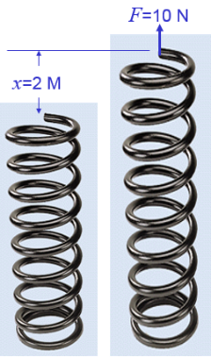 ______________________________________

It takes 10 Newtons to stretch a spring 2 meters beyond its natural length.

We can determine, F = 5x, we can use this to determine:

How much work is done stretching the spring to 4 meters beyond its natural length?

Well, for a small change in x, dx, and if F(x) = 5x, therefore, (5x)dx, so we can use:

**HW: section 7.1**

#s:1 – 8 all, 29, 30